**Reverse Revenue Task**

**Case 1:**

Sales Order :

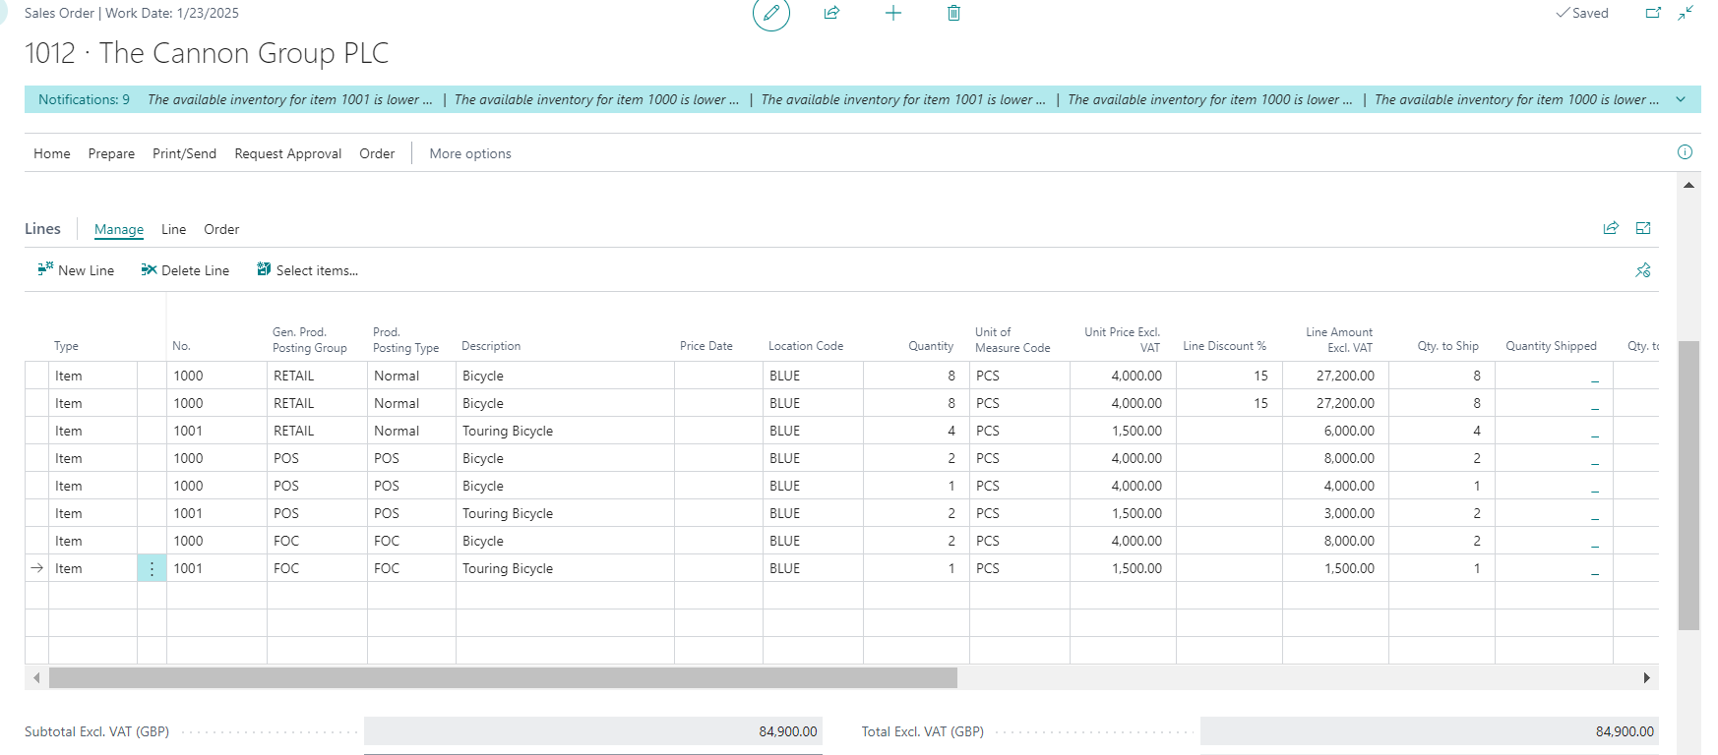

Dimension:

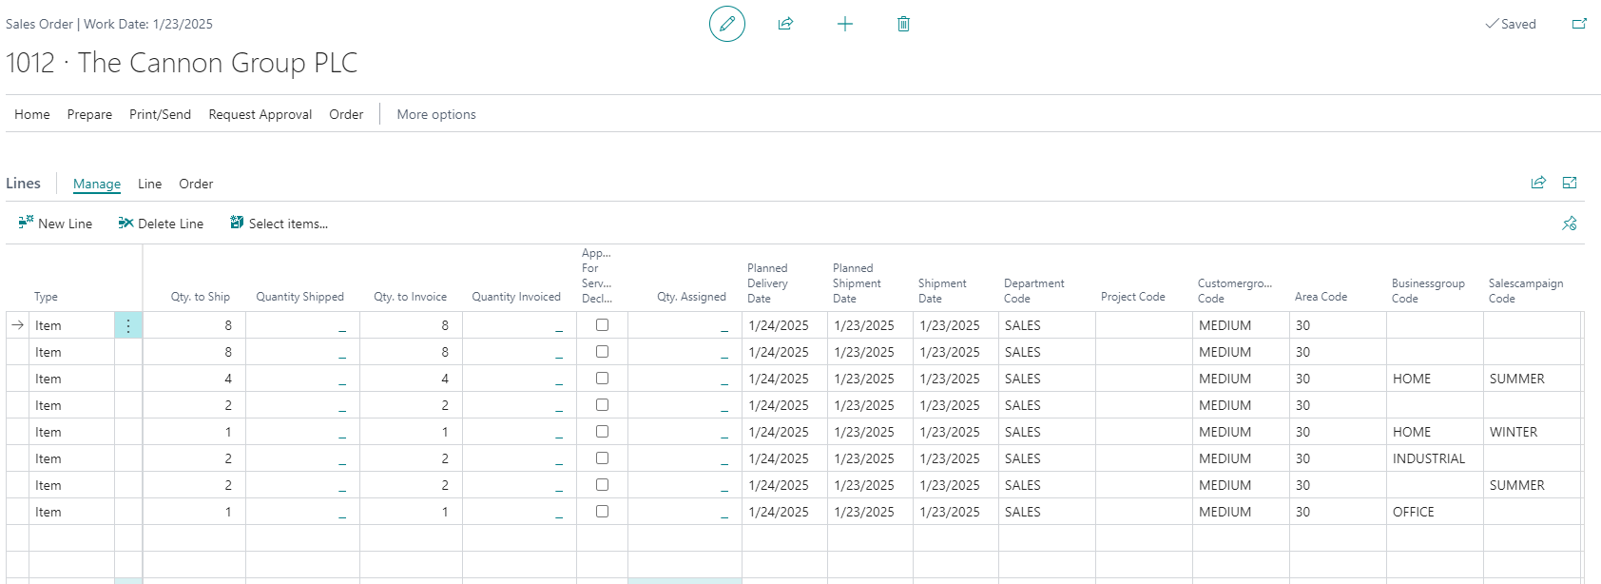

Posted Sales Invoice:

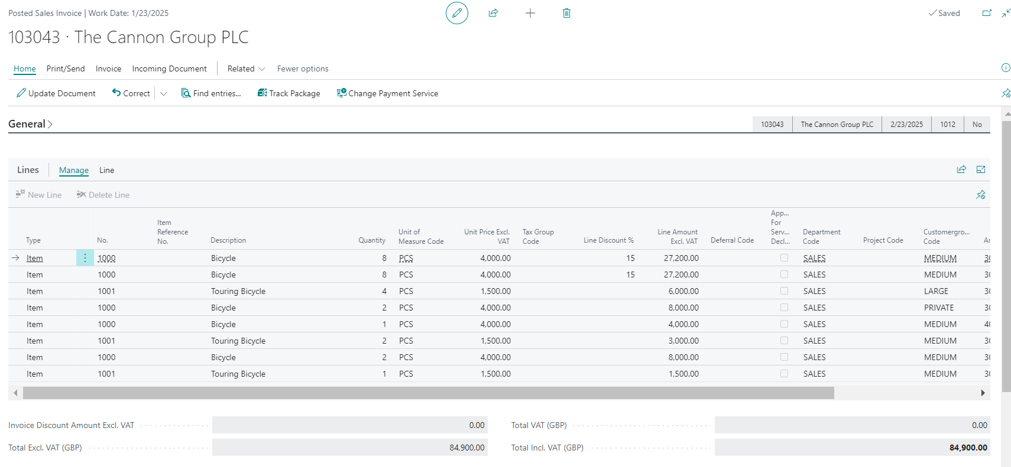

Dimension:

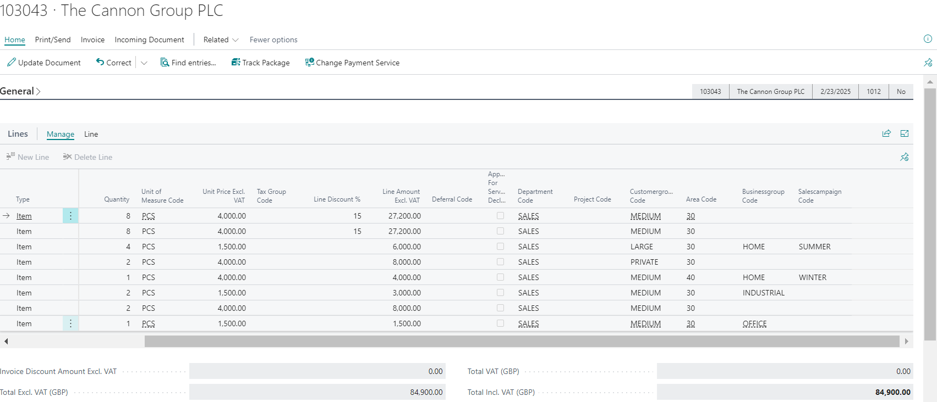

General Journal:

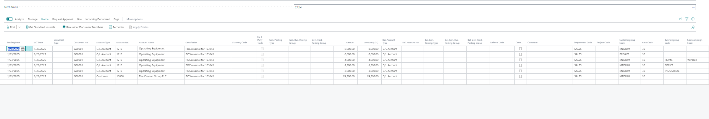

General Journal Line :2

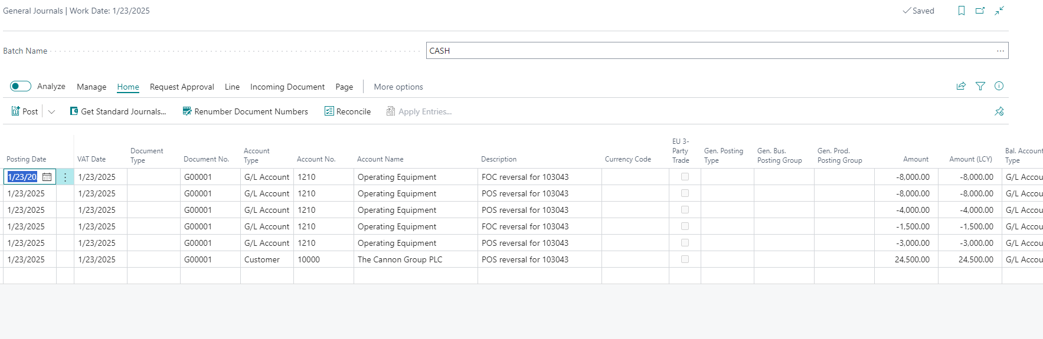

General Journal Line :3

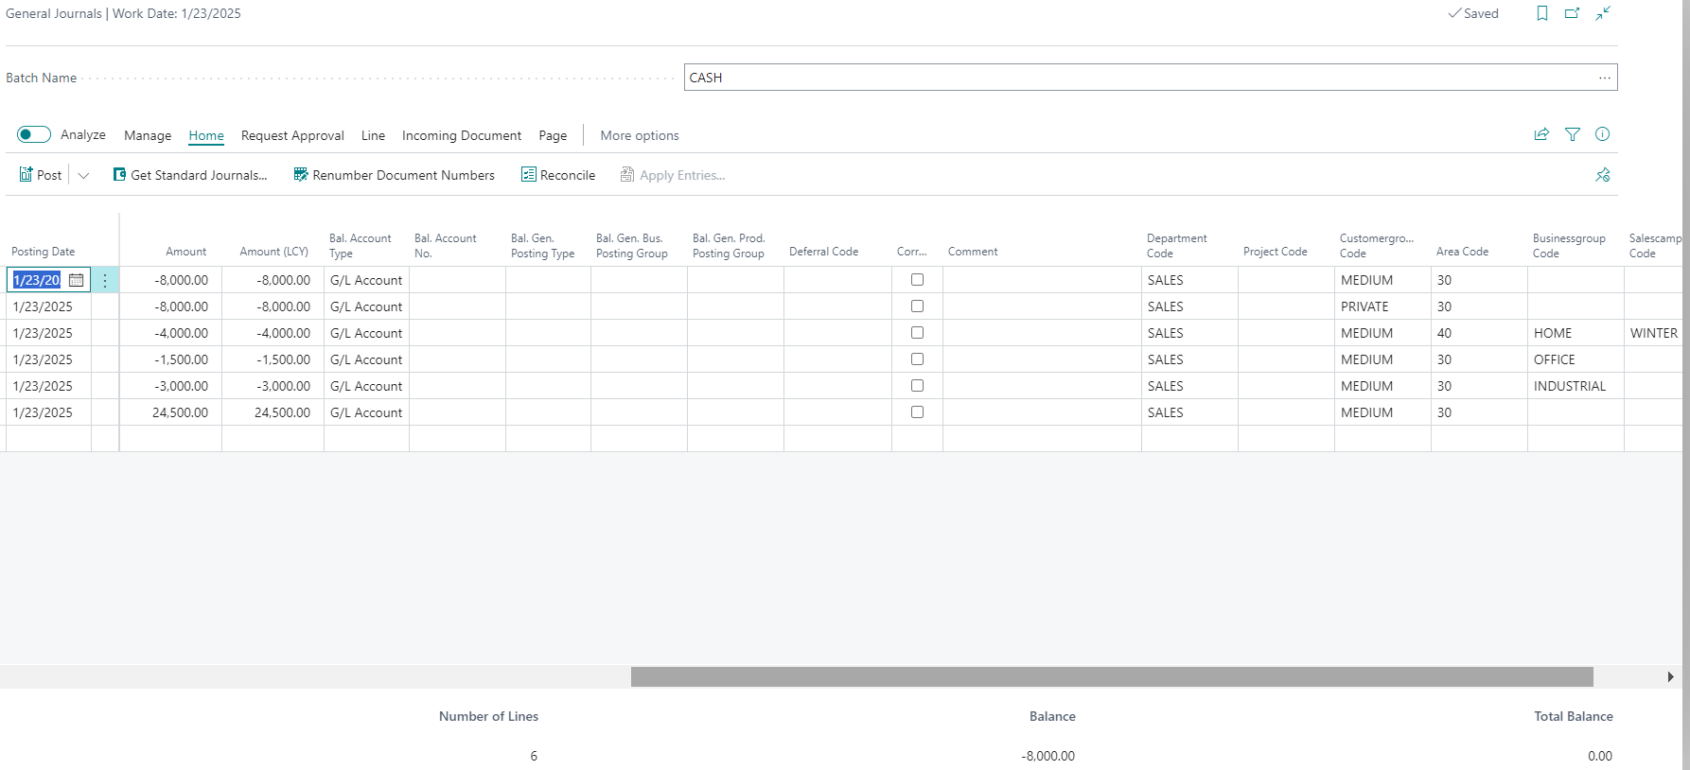

Case 2: **Reverse Revenue for FOC Items**

Sales Setup:

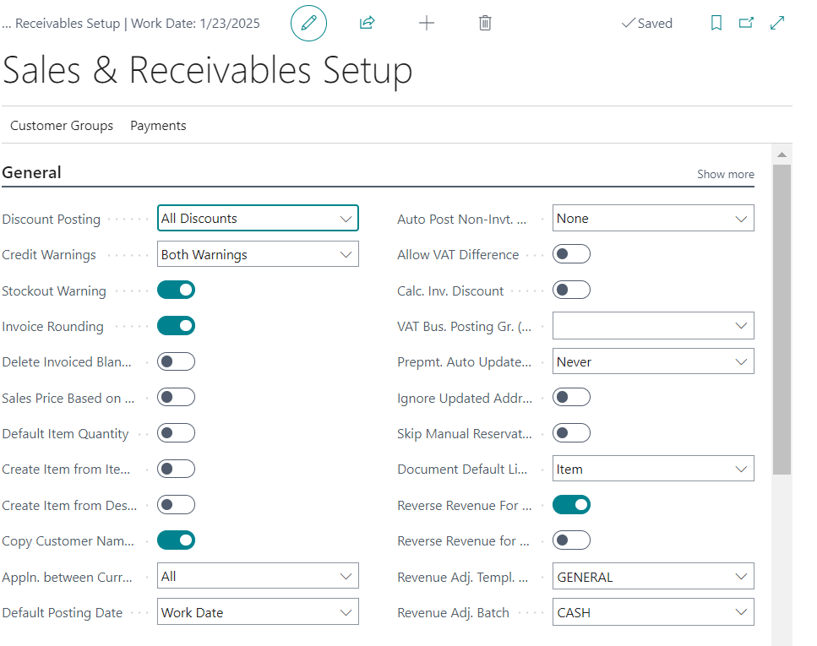

General Journal:

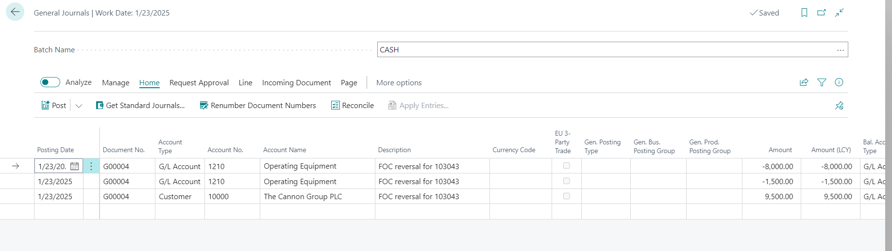

Case 3 **Reverse Revenue for POS Items**

Sales Setup:

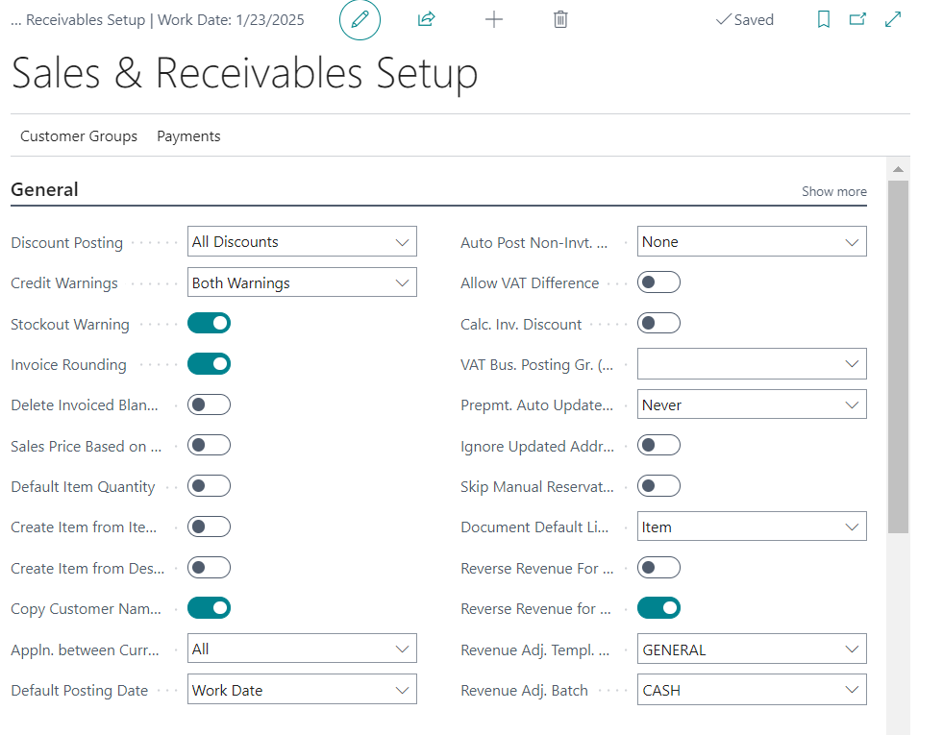

General Journal :

